**DAILY ONLINE ACTIVITIES SUMMARY**

|  |  |  |  |  |  |  |  |  |
| --- | --- | --- | --- | --- | --- | --- | --- | --- |
| **Date:** | **26/06/2020** | | | | | **Name:** | **Lavanya D M** | |
| **Sem & Sec** | **4th & ‘A’** | | | | | **USN:** | **4al18cs041** | |
| **Online Test Summary** | | | | | | | | |
| **Subject** | | **----** | | | | | | |
| **Max. Marks** | | **----** | | **Score** | | | **-----** | |
| **Certification Course Summary** | | | | | | | | |
| **Course** | EIGRP Course | | | | | | | |
| **Certificate Provider** | | | **Bitdegree** | | **Duration** | | | **1week** |
| **Coding Challenges** | | | | | | | | |
| **Problem Statement:**  1) Given start and end of a range, write a Python program to print all negative numbers in given range  2) Java program to print pulse Triangle Star Pattern | | | | | | | | |
| **Status: Complied** | | | | | | | | |
| **Uploaded the report in Github** | | | | | **yes** | | | |
| **If yes Repository name** | | | | | <https://github.com/lavanyamurthi/lockdown-coding> | | | |
| **Uploaded the report in slack** | | | | | **yes** | | | |

Online Test Details: (Attach the snapshot and briefly write the report for the same)

Webinar:

Today class is conducted on Cyber security by Manjunath sir in which we learn about the concept of Cyber security , and even we had quiz regarding that

Certification Course Details: (Attach the snapshot and briefly write the report for the same)

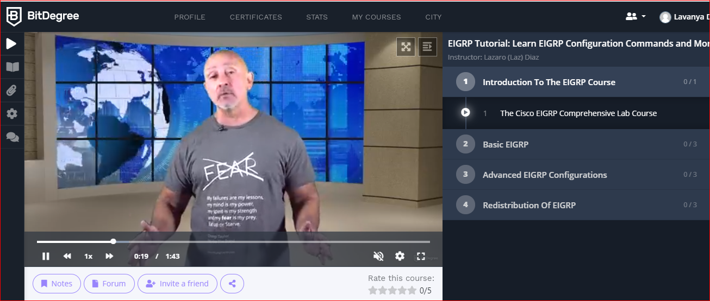

Coding Challenges Details: (Attach the snapshot and briefly write the report for the same)

**Problem 1** : Given start and end of a range, write a Python program to print all negative numbers in given range

Example: Input: start = -4, end = 5 Output: -4, -3, -2, -1 Input: start = -3, end = 4 Output: -3, -2, -1

|  |
| --- |
|  |
|  |  |

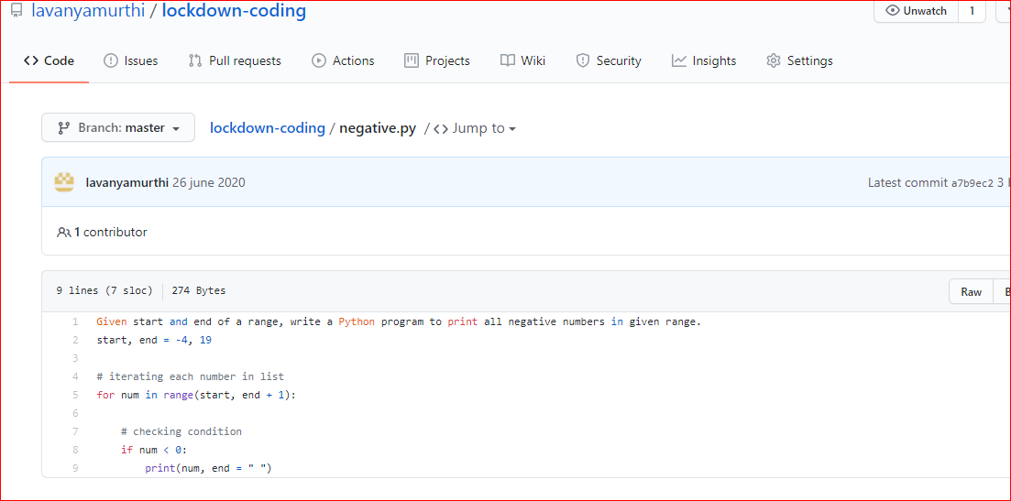

**Problem 2:**  Java program to print pulse Star Pattern

